Making the WiFi configurable.

Hard coding the WiFi credentials (SSID and Passphrase) is not a professional solution. Instead there are alternatives to make the ESP detect when it can’t reach a known network and then decide to act as an Access Point itself. The user accesses this AP and logs in to an HTTP server on the board to enter the SSID and Passphrase. Then the board will cease the AP and restart in the Station mode connecting to configured network.

There are several libraries to implement the above behavior, however I found “WifiManager by tzapu” to the oldest and the best.

To install it:
Sketch → Include Library → Manage Libraries (CTRL-SHIFT-I)

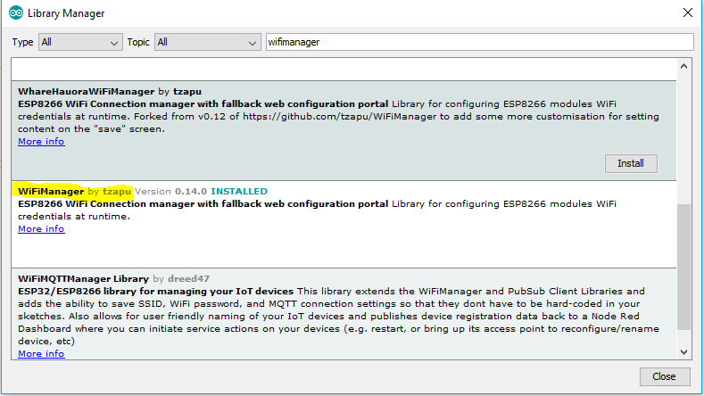
You are free to experiment with others, but this is the one to try out for now.

Now once you have it installed, restart the IDE if necessary and go to the example :

File → Examples → (under Examples from Custom Libraries) WifiManger → AutoConnect

Study the Example and try to project it on your work from now on.

In any sketch you need to add 4 Elements:

1) the Includes:
#include <DNSServer.h>
#include <ESP8266WebServer.h>
#include <WiFiManager.h>

2) in the “setup” you need to instantiate a class
WiFiManager wifiManager;

3) also in setup start the wifiConfig with the name of the temporary access point.
wifiManager.autoConnect("AutoConnectAP");

4) optional print the connected IP
Serial.println("");
Serial.println("WiFi connected");
Serial.println("IP address: ");
Serial.println(WiFi.localIP());

To be able to force the effect of the WifiConfig, you need to need to erase previous settings of the wifi from the ESP flash memory.
Tools → Erase Flash …. → Sketch+WiFi Settings

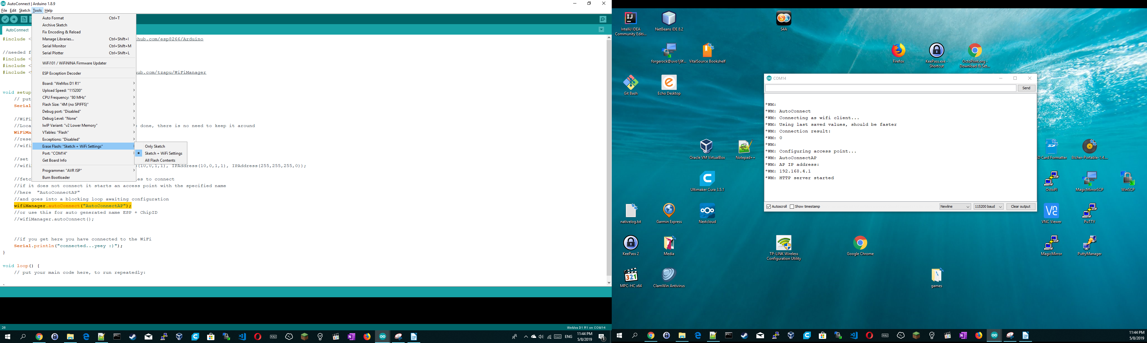

Really you will never regret adding the WifiManager to every sketch you code from now on.

Once the ESP detects itself with no known network, it will start an Access point with the name specified in code as “AutoConnect”.

Once connected, click the Wifi Settings and click the “Manage Router” link and you will see the WiFiManager Page. From there you could scan surrounding WiFi’s or enter directly the SSID and Passphrase without scanning for (hidden wifi’s)

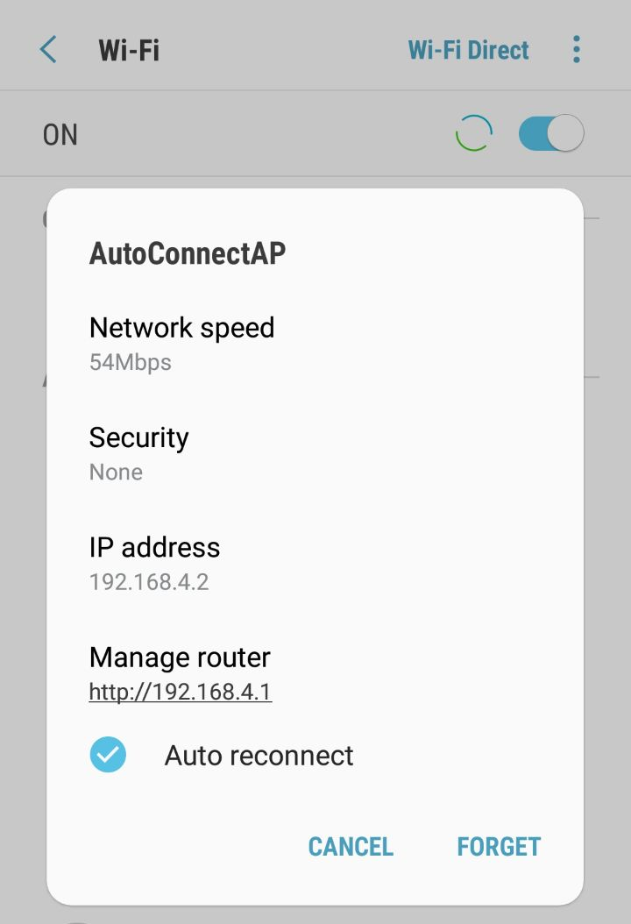 | 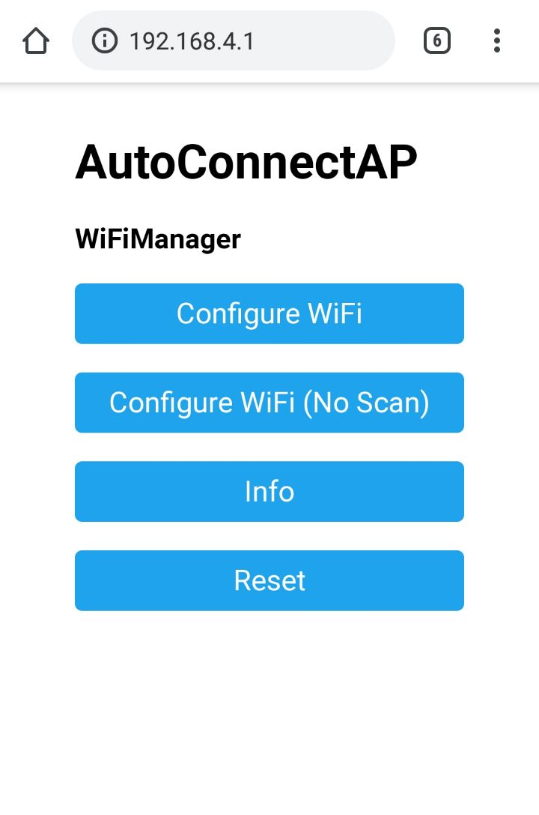

If everything goes fine, the AutoConnectAP will shutdown and disappear and you will see the ESP connected to your chosen SSID.

